SUT Indicator Issue

Note: Same Solution worked in SAM2210 but it is not working in SAM2405.
Requirement: Adding SUT Indicator field in the notification detail page in SAM 2405.
Issue: SUT Indicator value is coming for notification in the backend as well as odata service but it is not coming in the MDK notification detail page context. Same solution worked in SAM 2210 but not working in SAM 2405.
Syclo Change: Below field is added in the ‘MyNotificationHeader’ Entity in the OData Model Configuration

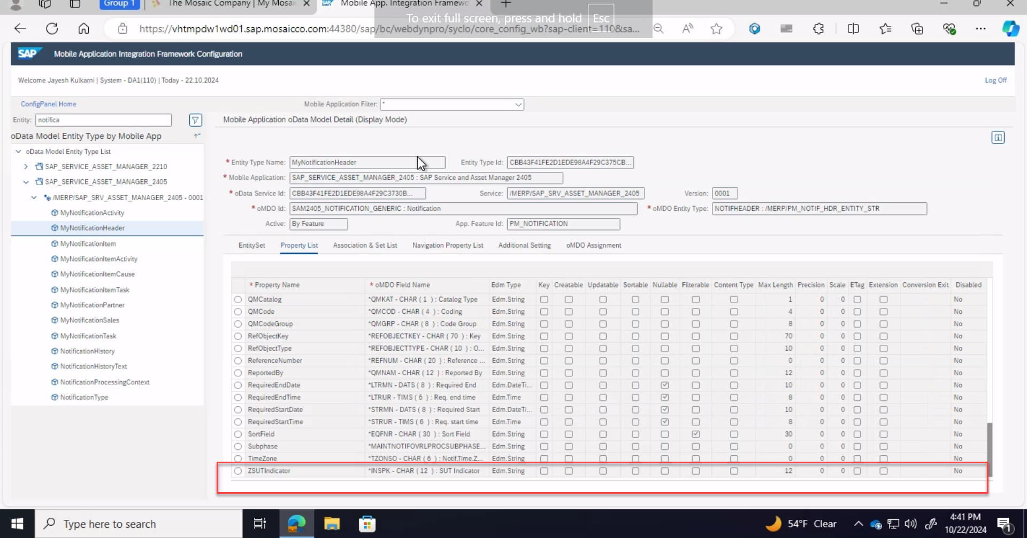

MDKChange:
- NotificationDetail.page
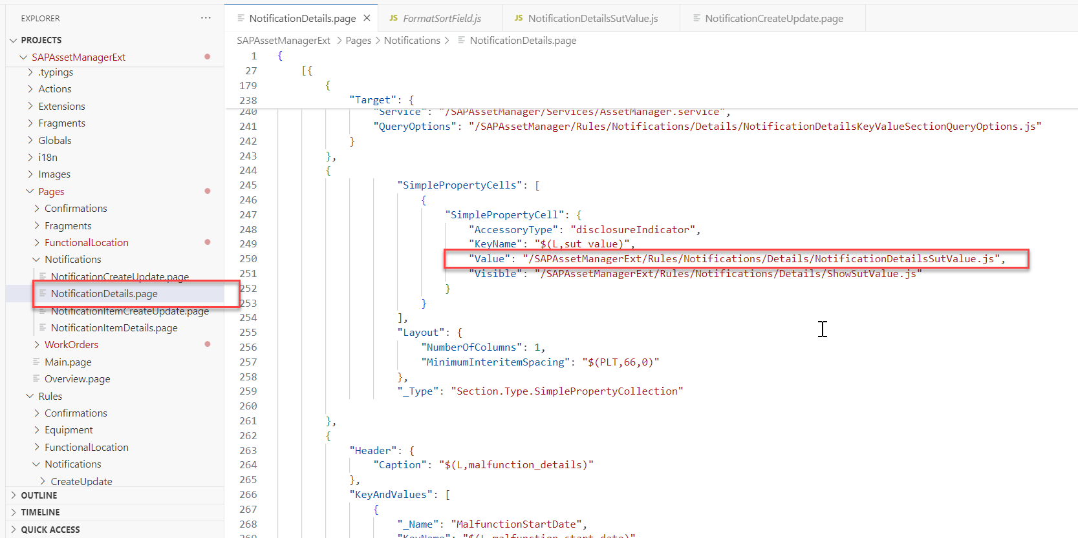

- Value rule
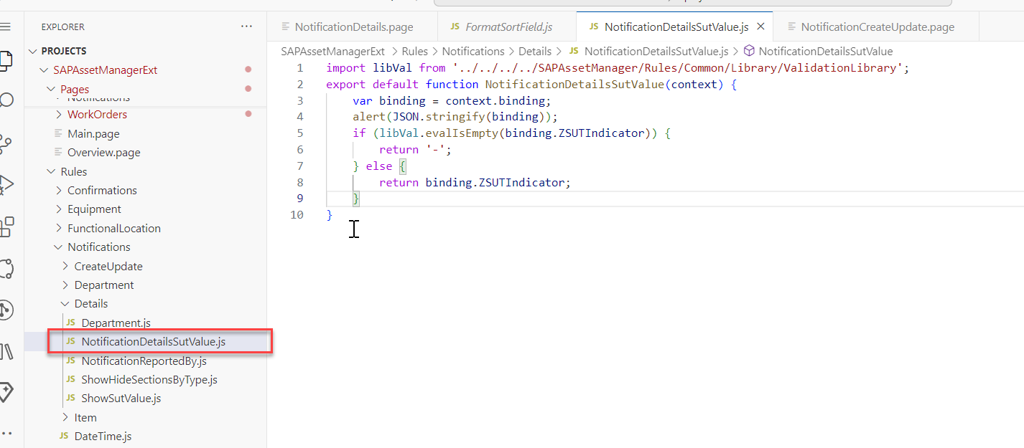

Below is the print for context.binding of the value rule

